## Merchant Interfold

Scoping start date: May 3, 2024

Implementation Completed Date (Go live date): May 10, 2024

MSA Signature Date: Feb 7, 2024

GTM POC: Ben

ERP: QBO

Tax Integration: No Tax

### 

### Key people at Merchant

### George Li - Co-Founder and CEO

### Company summary

Interfold works with banks to make commercial lending easy

“Solve your lending bottlenecks with digital experience and AI –so you can 2x loan volume and turnaround loans in days, not weeks.”  
  
AM Notes

* ~~George and Ali have a personal relationship~~

### Billing model

* Merchant bills platform fees which are a fixed amount that is priced per month
* Pilot periods are usually billed at a lower amount and are billed monthly
* After the pilot period, bills increase in amount and are billed monthly or annually  
  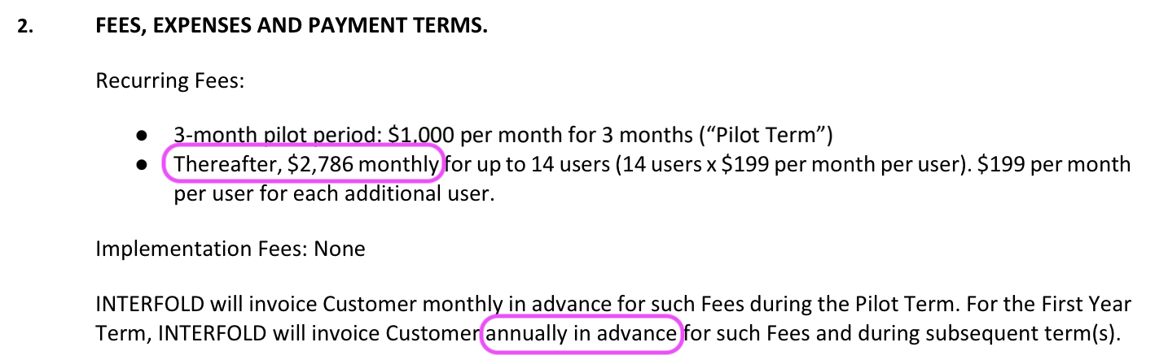

### Contract Processing Steps

1. Create a customer in Garage (which will create it in QBO) if the customer does not exist
2. Look at the contract for Key Terms related to Cancellation Policy. That is the most important Key Term.
3. Create billing terms for the Pilot Period and Regular Period. Be sure to check if the Regular Period is billed monthly or annually.
4. All items should use the Integration Item “Services”
5. No billing terms are necessary to account for “$X fee per user for each additional user”. That is, there are no events for this merchant.

### Events Processing (if necessary)

* Currently they bill flat rates, but their contracts include provisions for additional users. For example the contract for Prime Alliance Bank is inclusive up “up to 7 users” and they would like to be able to capture growth on top of that
  + **For now, do not process any events-based billing terms.**

### Customer Information

* None

### Feature Requests

* None

### Rewatch Calls

* [George + Ali & Ben - custom demo - April 26, 2024 - Watch Video](https://tabs.rewatch.com/video/cjgfm74iipxxsv83-george-ali-ben-custom-demo-april-26-2024)
* Onboarding call 1: <https://tabs.rewatch.com/video/3airhbz0z55unnr4-tabs-interfold-implementation-kick-off-may-3-2024>